|  |  |
| --- | --- |
| 657092712 | https://www.sjos.cn/EN/1006-7248/current.shtml |

Go to the website using the bases url

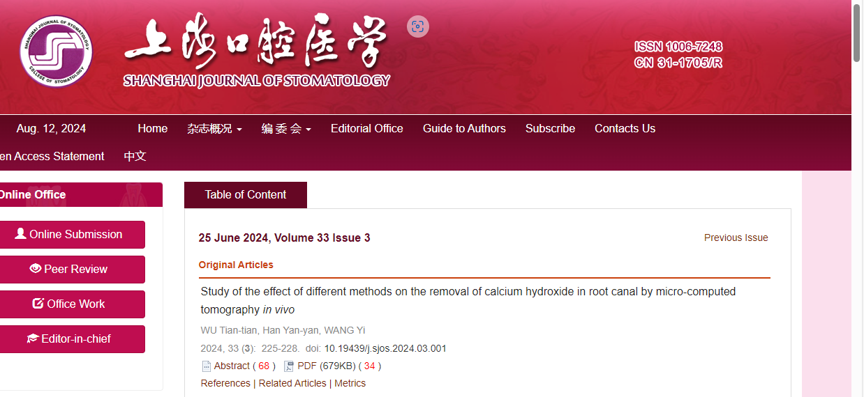

DOI

Date

month

Capture volume

Capture issue

Article title

Page range

Need both non roman and English tocs